Structural and visual outcome of atypical solar exposure following religious rituals

**Running title: solar maculopathy**

Amal M Elbendary MD1,2 **,** Ola Abd Elaal MS2

1. Mansoura Ophthalmic Centre, Mansoura University
2. Mostakbal Eye Centre

**Corresponding author details:**

Name: Amal M Elbendary

Affiliation: Mansoura Ophthalmic Centre, Mansoura University. Mostakbal Eye Centre, Mansoura, Egypt

Postal address: Mansoura Ophthalmic Centre, Gomhoria Street, Mansoura, Egypt. Zip code: 35516

Email: amalelbendary67@gmail.com

Phone: 0020502212285, 00201063838760

Fax**:** 2256104

**Keywords** solar retinopathy; Trauma; Optical coherence tomography; religious rituals.

We have no proprietary interest in any material or method mentioned.

No grants or funds have been received in the support of this study.

**Structural and visual outcome of atypical solar exposure following religious rituals**

Abstract:

A 28 years old female presented with bilateral defective vision (0.4 and 0.6 Log Mar in right and left eye respectively) and bilateral scotomas. Anterior and posterior segment examination were unremarkable. Interrogation with patient disclosed recent prolonged sun gazing on 27th Hijri month, Ramadan, searching for holy “lailat Elkader”. Optical coherence tomography revealed bilateral defect in inner segment /outer segment (IS/OS) junction and outer segment of photoreceptor layer (PRL) and retinal pigment epithelium (RPE). A bilateral symmetrical cone shaped area of infiltration was seen extending from outer into inner retinal layers. One month later, vision was partially improved (0.3 in right eye and 0.5 in left eye) with persistent defect in outer segment of PRL and IS/OS junction in right eye while resolution of infiltration, partial recovery of IS/OS junction and RPE was more evident in left eye.

Introduction

Solar retinopathy is a rare clinical entity that typically occurs following prolonged gazing to sunlight during solar eclipse. 1 Atypical exposure may occur during sunbathing, military activities, mental illness and religious rituals.1,2,3 The definition has extended to include direct or indirect solar gazing during either a solar eclipse or on a normal day.3

Photic injury is typically seen in young individuals and can give rise to defective vision of varying severity, subjective visual disturbances in the form of metamorphopsia, scotomas and morphological foveal changes.4 Spectral domain optical coherence tomography(SD-OCT) proved to be an effective tool for diagnosing subtle lesions not detected on fundus photography or fluorescein angiography.5

The aim of this work is to report the structural and visual outcome of a case of atypical solar retinopathy following prolonged sungazing during religious rituals and to discuss the possible etiology and prevention

Case report

Female patient aged 28 years presented with bilateral defective vision and scotoma few days earlier. No history of trauma, glasses, medication, systemic or local eye disease was associated. To reach a reasonable precipitating factor, she was asked about history of abnormal light exposure. She denied exposure to commercially available laser pointer widely spread in our community. However, she recalled a history of unprotected sun gazing one week ago at sun rise on 27th day of holy Hijri month, Ramadan. The patient stared directly at the weak sun for prolonged period lasting about fifteen minutes. Best corrected visual acuity was 0.4 and 0.6 Log Mar in right and left eye respectively. Intraocular pressure measurement in right and left eye was 14 mmHg. Anterior segment examination revealed no abnormality. Fundus examination revealed abnormal foveal light reflex. Fluorescein angiography (FA) showed no leakage or window defects. On SD-OCT (Cirrus HD-OCT, Carl Zeiss Meditec, Dublin, CA) macular map revealed bilateral normal macular thickness. The foveal region in both eyes revealed interruption of IS/OS (inner segment-outer segments) junction of PRL (Photoreceptor layer). This finding was associated with bilateral defect in outer segment of PRL and retinal pigment epithelium (RPE). A bilateral symmetrical cone shaped area of infiltration was seen extending from IS/OS junction into inner retinal layers blending with outer plexiform layers (figure 1,2). One month later, the patient BCVA improved to 0.3 in right eye and 0.5 in left eye but the scotoma persisted in both eyes. She was subjected to scanning with SD-OCT (3D OCT 1000 (Topcon Corp., Tokyo, Japan) In the right eye, the defect persisted in outer segment of PRL and IS/OS junction with RPE depigmentation and relative disappearance of infiltration leaving behind a hollow track emanating from IS/OS (figure 3). In the left eye, the RPE defect disappeared, while defect in IS/OS junction and outer segment of PRL partially improved with clearance of cone shaped infiltration (figure 4).

Discussion

The incidence of solar retinopathy is relatively low and a history of sun exposure may be lacking.3 The classic acute and chronic exposure is during solar eclipse 6,7,8,9. Nowadays, public are more oriented about solar eclipse and usually use protective googles because of awareness about the deleterious effect of infrared rays during the eclipse 5. However, little is known about religious rituals because of scarce number of recorded cases and the fact that in our sunny countries most people are just trying to detect sun appearance. We are not aware of a recent imaging study of solar retinopathy following religious rituals in middle east region. In addition, the present study reveals that the characteristic OCT image of outer retinal layers defect was the clue to redirect the attention to seek for undisclosed history of sun gaze.

In 1988, Hope-Ross described 2 a series of four pilgrims who suffered irreversible visual damage with persistent central scotomata after looking at the sun for prolonged periods of time.

Young people remain the most vulnerable age group to solar retinopathy because of higher exposure and the fact that their lens has greater transparency.10

Muslim worshipers monitor the last ten days of the Hijri month, Ramadan, searching for holy “lailat Elkader”. It is believed that odd nights especially the 27Th night is the most appreciated as the target night. Landmarks of the holy night is the peculiar appearance of sunrise, that is weak sky with white rayless sun facilitating prolonged gazing.

Histopathologic studies revealed that in the early stages there is damage to the RPE, with edema, irregular pigmentation, and frank necrosis. In the later stages there is fine structural abnormalities including; focal loss of rod and cone nuclei and depigmentation of RPE. 11,12 Tomographic OCT images correlated well with histologic findings. Earlier OCT images after exposure showed RPE defect, interruption in IS/OS junction and outer segment of PRL with infiltration extending from IS/OS junction to inner retinal layers. While images taken one month later showed partial subsidence of infiltration, depigmentation of RPE and persistence of defects in IS/OS and outer segment of PRL in the dominant eye. These tomographic findings also correlated with partial improvement of visual acuity after one month.

Thermal, photochemical, and photomechanical reactions are suggested to be the pathogenic mechanisms for solar retinopathy.13 It is assumed that prolonged exposure may excites a sterile inflammatory response in acute stage seen in our case as infiltration in the outer retina extending to inner retinal layers. After subsidence of acute stage, the infiltration was resolved.

In conclusion, people are less oriented with atypical incidents of sun exposure during religious rituals necessitating the need to educate and aware the public particularly vulnerable groups to avoid prolonged, unprotected sun gaze. Imaging with OCT is highly valuable for early detection and follow up of outer retinal damage in cases with undisclosed history of sun exposure.

**References**

1-Yannuzzi LA, Fisher YL, Krueger A, Slakter J. Solar retinopathy: A photobiological and geophysical analysis. Trans Am Ophthalmol Soc. 1987;85:120–58.

2-Hope-Ross M, Travers S, Mooney D. Solar retinopathy following religious rituals. Br J Ophthalmol. 1988, 72, 931-934.

3-Comander J, Gardiner M, Loewenstein J. High-resolution optical coherence tomography findings in solar maculopathy and the differential diagnosis of outer retinal holes. Am J Ophthalmol. 2011;152(3):413-9.

4- Fredrik FP, Jan Ygge J.Photo-induced foveal injury after

viewing a solar eclipse. Acta Ophthalmol. Scand. 2005: 83: 586–589.

5- Kung YH, Wu TT, Sheu SJ. Subtle solar retinopathy detected by fourier-domain optical coherence tomography. J Chin Med Assoc. 2010;73(7):396-8.

[6-Bech](https://www.ncbi.nlm.nih.gov/pubmed/?term=BECHMANN%20M%5BAuthor%5D&cauthor=true&cauthor_uid=10847708)mann M,  [E](https://www.ncbi.nlm.nih.gov/pubmed/?term=EHRT%20O%5BAuthor%5D&cauthor=true&cauthor_uid=10847708)hrt O,  [T](https://www.ncbi.nlm.nih.gov/pubmed/?term=THIEL%20M%5BAuthor%5D&cauthor=true&cauthor_uid=10847708)hiel M,  [Kris](https://www.ncbi.nlm.nih.gov/pubmed/?term=KRISTIN%20N%5BAuthor%5D&cauthor=true&cauthor_uid=10847708)tin N,  [Ulb](https://www.ncbi.nlm.nih.gov/pubmed/?term=ULBIG%20M%5BAuthor%5D&cauthor=true&cauthor_uid=10847708)ig M, [Kam](https://www.ncbi.nlm.nih.gov/pubmed/?term=KAMPIK%20A%5BAuthor%5D&cauthor=true&cauthor_uid=10847708)pik A. Optical coherence tomography findings in early solar retinopathy. [Br J Ophthalmol](https://www.ncbi.nlm.nih.gov/pmc/articles/PMC1723486/). 2000; 84(5): 546.

7-[Wu CY](https://www.ncbi.nlm.nih.gov/pubmed/?term=Wu%20CY%5BAuthor%5D&cauthor=true&cauthor_uid=29222532), [Jansen ME](https://www.ncbi.nlm.nih.gov/pubmed/?term=Jansen%20ME%5BAuthor%5D&cauthor=true&cauthor_uid=29222532), [Andrade J](https://www.ncbi.nlm.nih.gov/pubmed/?term=Andrade%20J%5BAuthor%5D&cauthor=true&cauthor_uid=29222532), [Chui TYP](https://www.ncbi.nlm.nih.gov/pubmed/?term=Chui%20TYP%5BAuthor%5D&cauthor=true&cauthor_uid=29222532), [Do AT](https://www.ncbi.nlm.nih.gov/pubmed/?term=Do%20AT%5BAuthor%5D&cauthor=true&cauthor_uid=29222532), [Rosen RB](https://www.ncbi.nlm.nih.gov/pubmed/?term=Rosen%20RB%5BAuthor%5D&cauthor=true&cauthor_uid=29222532), [Deobhakta A](https://www.ncbi.nlm.nih.gov/pubmed/?term=Deobhakta%20A%5BAuthor%5D&cauthor=true&cauthor_uid=29222532).

Acute solar retinopathy imaged with adaptive optics, optical coherence tomography angiography, and en face optical coherence tomography. Jamaophthalmol 2018 ;136(1):82-85.

8-Shukla D. Optical coherence tomography and autofluorescence findings in chronic phototoxic maculopathy secondary to snow-reflected solar radiation. Indian J Ophthalmol. 2015 ; 63(5): 455–457.

9-[Chen RW](https://www.ncbi.nlm.nih.gov/pubmed/?term=Chen%20RW%5BAuthor%5D&cauthor=true&cauthor_uid=19756263), [Gorczynska](https://www.ncbi.nlm.nih.gov/pubmed/?term=Gorczynska%20I%5BAuthor%5D&cauthor=true&cauthor_uid=19756263) , [Srinivasan VJ](https://www.ncbi.nlm.nih.gov/pubmed/?term=Srinivasan%20VJ%5BAuthor%5D&cauthor=true&cauthor_uid=19756263), [Fujimoto JG](https://www.ncbi.nlm.nih.gov/pubmed/?term=Fujimoto%20JG%5BAuthor%5D&cauthor=true&cauthor_uid=19756263), [Duker JS](https://www.ncbi.nlm.nih.gov/pubmed/?term=Duker%20JS%5BAuthor%5D&cauthor=true&cauthor_uid=19756263), [Reichel E](https://www.ncbi.nlm.nih.gov/pubmed/?term=Reichel%20E%5BAuthor%5D&cauthor=true&cauthor_uid=19756263). High-Speed Ultrahigh-Resolution Optical Coherence Tomography Findings in Chronic Solar Retinopathy. Retin Cases Brief Rep. 2008 ; 2(2): 103–105

10- [Stock RA](https://www.ncbi.nlm.nih.gov/pubmed/?term=Stock%20RA%5BAuthor%5D&cauthor=true&cauthor_uid=23828473)1, [Savaris SL](https://www.ncbi.nlm.nih.gov/pubmed/?term=Savaris%20SL%5BAuthor%5D&cauthor=true&cauthor_uid=23828473), [de Lima Filho EC](https://www.ncbi.nlm.nih.gov/pubmed/?term=de%20Lima%20Filho%20EC%5BAuthor%5D&cauthor=true&cauthor_uid=23828473), [Bonamigo EL](https://www.ncbi.nlm.nih.gov/pubmed/?term=Bonamigo%20EL%5BAuthor%5D&cauthor=true&cauthor_uid=23828473). Solar retinopathy without abnormal exposure: case report. Arq Bras Oftalmol. 2013;76(2):118-20

11- Gass JDM. Stereoscopic atlas of macular diseases: diagnosis and

treatment. St Louis: Mosby, 1977: 322-325.

12- Hope-Ross MW, Mahon GJ, Gardiner TA, Archer DB. Ultrastructural findings in solar retinopathy. Eye. 1993;7:29---33.

13- Wu J, Seregard S, Algvere PV. Photochemical damage of the retina. Surv Ophthalmol. 2006;51:461–81.

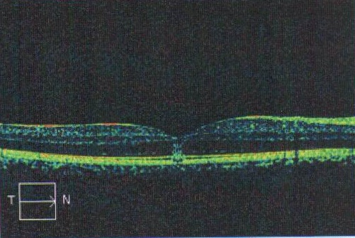

Figure 1: Optical coherence tomography of the right eye reveals interruption of IS/OS (inner segment-outer segments) junction of pphotoreceptor layer, defect in outer segment of PRL and retinal pigment epithelium. A cone shaped area of infiltration extends from IS/OS junction into inner retinal layers blending with outer plexiform layers.

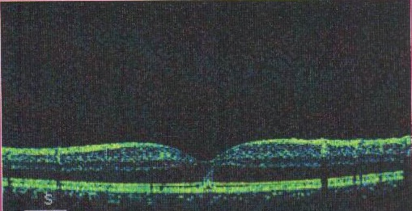

Figure 2: Optical coherence tomography of the left eye reveals interruption of IS/OS (inner segment-outer segments) junction of photoreceptor layer, defect in outer segment of PRL and retinal pigment epithelium. A cone shaped area of infiltration extends from IS/OS junction into inner retinal layers blending with outer plexiform layers.

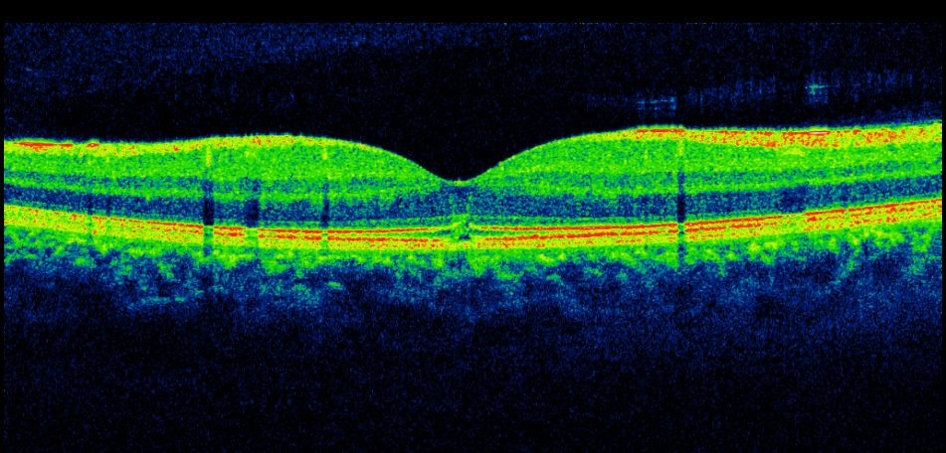

Figure 3: Optical coherence tomography of the right eye after one month reveals persistent defect in outer segment of pphotoreceptor layer and IS/OS (inner segment-outer segments) junction with depigmentation of retinal pigment epithelium and relative disappearance of infiltration leaving behind a hollow track emanating from IS/OS.

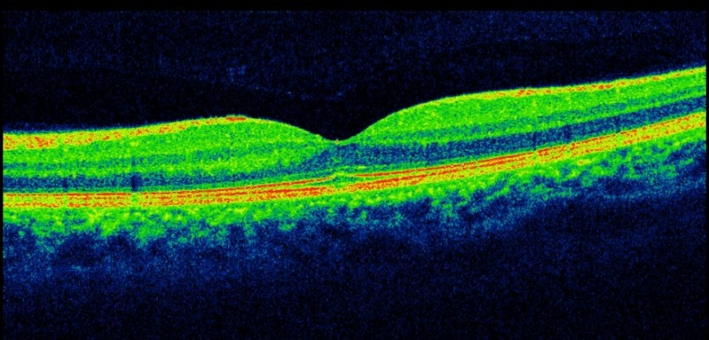

Figure 4: Optical coherence tomography of the left eye after one month reveals disappearance of defect in retinal pigment epithelium, partially improved defect in IS/OS (inner segment-outer segments) junction and outer segment of pphotoreceptor layer and clearance of cone shaped infiltration emanating from IS/OS junction.